SWOT and PEST analysis for a construction supply company.

**SWOT:**

­­This is defining the strengths, weaknesses, opportunities and threats of a project.

**Strengths:**

* **Experienced Staff**: Our company has a well experienced and skilled team of drivers and logistics who both understand the importance of transporting construction materials efficiently.
* **Knowledge of the Environment:** Our deep understanding of Kano state and all its transportation networks gives us an advantage in navigating throughout the state and its traffic patterns.
* **Reliability:** We own a fleet of qualitative trucks that can handle the transportation of construction materials and ensure safe and on time deliveries.

**Weakness:**

* **Ongoing Technological Transition:** As we work on integrating new technology into our company, there might be a period of adjustment that might affect our operations until the new system is fully implemented and optimized.

**Opportunities:**

* **Construction Boom:** The current increase in construction projects in Kano presents an opportunity to for us as the demand for transportation of construction materials is growing.
* **Expansion of Kano Neighbors:** Expanding our services to neighboring cities where currently construction is also booming can widen our market reach.
* **Technological advancements:** We could implement more technology into the company to have an edge over our competitors, technology like Machine Learning to optimize our operations and customer services, and an auditing system to track and store all activities within the company.

**Threats:**

* **Intensified Competition:** As the construction industry is currently growing, new competitors are entering the market, leading to price competition and service quality challenges.
* **Regulatory Changes:** Transportation costs could increase due to changes in regulations and requirements of the state.
* **Economic Instability:** With the current economic situation of the country, our business volume could also be affected as others are minimizing costs.

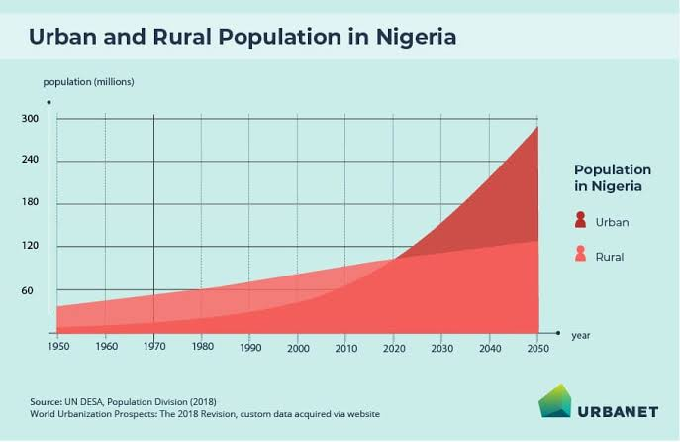

**PEST:**

This is defining how politics, economy, social and technological factors affect the project.

**Political factors:**

* **Regulations:** regulations and policies of transportation set by the government could affect our operations and strategies.
* **Permits and Licenses:** Legal permits and licenses could affect our services to clients smoothly.
* **Political Stability:** A stable political environment would surely enhance our operations without any interruptions and would definitely be advantageous to our long-term business plans.

**Economic factors:**

* **Economic growth:** A growing economy would definitely be beneficial to us as it will lead to more construction projects.
* **Inflation:** This could lead to higher operating costs which could affect our profits if not managed effectively.
* **Exchange Rates:** Fluctuations in foreign currencies might impact our cost of imported goods which will affect our overall expenses.

**Social Factors:**

* **Construction Trends:** The current construction models and materials among builders, engineers and contractors will affect the kinds of goods we transport.
* **Environmental Awareness:** The environment we would transport the construction goods to needs to be analyzed in order to maintain the quality of transported goods and transportation materials.
* **Labor Market:** Hiring skilled drivers and logistics personnel is essential and would influence our hiring and training services.

**Technological Factors:**

* **Digital Solutions:** Advancements in route optimization software and tracking systems could enhance our delivery quality and customer experience.
* **Automation:** The adoption of AI and Machine Learning will definitely reduce our costs in management and reduce the need of manual labor.
* **Data Management:** Effective data analysis tools can help us identify trends, track our operations and enhance our strategic decisions.